Inquiry Activity • In Your Neighborhood
Chapter 4 Migrating Populations
Problem What is the local impact of seasonal migration?
Your Prediction
1. How do migratory animals contribute to your local animal population?

Background
In some communities, migratory animals are easy to spot—on the beaches of Florida, green sea turtles, or at the Ballard Locks in Seattle, migratory salmon. The coast of California draws tourists in droves to observe the migrations of monarch butterflies and gray whales. But even if you don’t live near migratory superstars, it’s possible you’ve noticed a local animal population grow and shrink with the seasons.
Local and global organizations monitor migratory populations. The “Birdnet” Audubon Web site offers local information on bird migrations. The “Caribbean Sea Turtle Conservation” page lets you track sea turtle migration. PBS has a whale migration site, and you can also track great white sharks and other marine predators on the “Tagging of Pacific Predators” site. Meanwhile, North American Butterfly Association and Kansas Monarch Watch both offer information about migratory butterflies.
North American Bird Migration Flyways
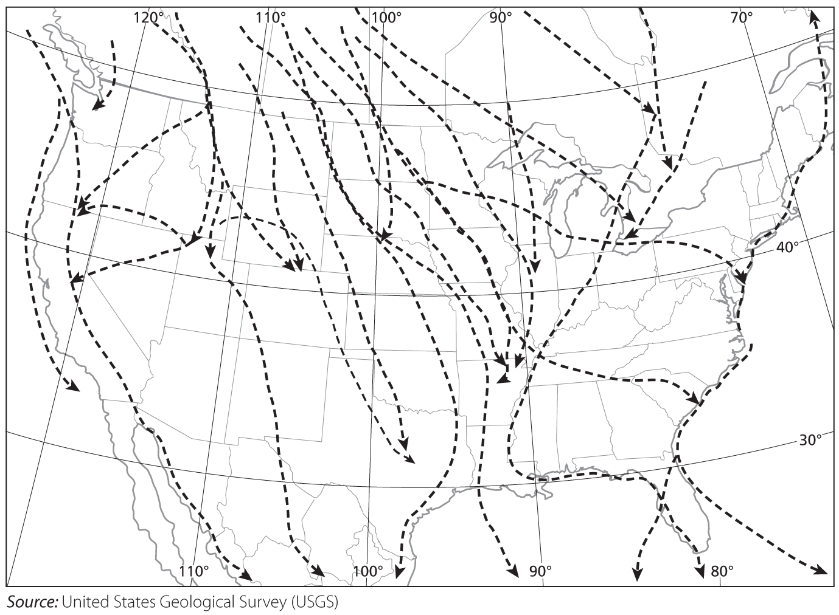
Research Your Local Environment
Procedure
Materials Computer with Internet access, and/or field guides listing local migratory species; graph template (in lab) or graph paper
Step 1 Find out which animals migrate seasonally through your region or state by contacting your local bird observatory, nature museum, aquarium, or wildlife park.
Step 2 Choose one migratory species. Use a field guide, encyclopedia, or credible Web sites to research the animal’s life cycle, predators, food sources, and habitat. Be sure to keep track of where you find different pieces of information so you can cite your sources later.
Step 3 Find out the migration patterns for the species. Learn where the animal lives locally, and for how long. (Note: Sources used in Step 2 may provide this information.)
Step 4 Contact a local source to learn more about the year-round population of this animal and how its habitats are protected. If you can’t find local information for steps 1–3, find information applying to a nearby region in your state. Be sure to cite your sources.
If you do not have Internet access, use information sources provided by your teacher in addition to those specified above.
Step 5 Read all the information and address the following questions.
Use your field guide research to answer Questions 2 and 3.
2. Describe one local migratory population. Describe its life cycle and mode of reproduction, habitat, food sources, and predators.

3. Draw a map of the local population’s migration route. Sketch the continents and important waterways, if necessary, in the migration route, and use a distinct line pattern or color for the route itself. Include the general seasons of migration, and mark any important stopovers and destinations.
Migration Route of ________________________ (Your Local Population)
KEY

Answer Questions 4 and 5 when you have completed your research.
- Create a Graph Make a line graph for your migratory species. Graph the local population fluctuations for your animal, by month for twelve months. Your graph can be limited to the migratory population of the species, or it can include data for the year-round population, depending on the information you gathered. (Use a separate sheet if necessary.) Use the x-axis for time and the y-axis for the population.

Analyze and Conclude
5. Communicate What are the boundaries of your animal’s local habitat? Why does it live in your area and how does it interact with other organisms?

6. Compare and Contrast Share your research and your graph with a partner or group. How do the local migratory populations compare and contrast? How do they interact, directly or indirectly?

7. Form an Opinion Consider your research. Do you think the population is healthy? Are you concerned by any of the data? Explain your reasoning.

8. Draw Conclusions Why would scientists want to monitor the migration habits of this species in your area? (Hint: Think about your answer for Question 5.)

Local to Global
9. Evaluate Your Prediction What new information have you learned about the effects of migratory animals on your local area? Have your ideas or opinions changed? Explain.

10. Think Globally In 2009, ornithologists in California predicted that global warming would cause unprecedented changes in bird populations. Specifically, global warming is expected to affect snow pack, rainfall, plant and tree distribution, prey, and predators. How have human pollution problems—at the global, regional, or local scale—affected the migratory animals in your area? How can people help migratory species survive these threats?

