Name ___________________
ACTIVITY 1-2
YOU’RE AN EYEWITNESS!

Directions: You will be given three minutes to study the picture distributed by your teacher. Then you will be asked to test your powers of observation by answering the questions provided.

- What time was it by the bank’s clock? ______________

- What day of the week was it? ________________

- What was the name of the outdoor café? ___________________

- On what street was the entrance to the restaurant? _____________________

- How many thieves are staging the holdup? ________________

- Were they armed? ___________________

- How many bags of loot were they carrying? _________________

- Was the thief in the street wearing a hat? _________

- How many people, besides you and the holdup men, were at the robbery? ________

- What were the initials of the man in the business suit? ____________

- What immediate danger was he in? _____________________________

- Was the onlooker from the second floor a man or a woman? __________

- What store was next to the café? __________________________________

- What was the shopper stealing? ________________________________

- What was the license number of the car parked in front of the store? ______

- How do you know the car was illegally parked? ____________________

- What part of the car was being vandalized? ________________________

- What type of hat is the person wearing who is vandalizing the car? ________

- What offense was in progress against the female diner? _________________

- What was the cost of the grapes? _________________

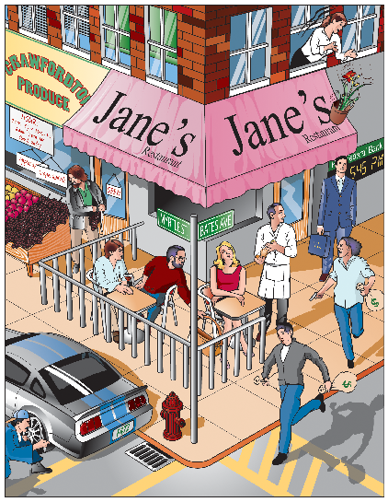
© Cengage Learning

