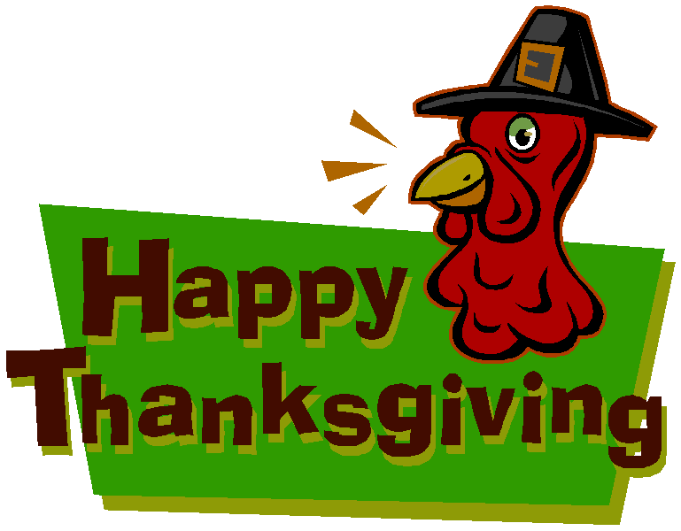
Name: Date:

GOBBLE GOBBLE ZZZZzzz
For years now, many people have claimed that after eating a Thanksgiving meal, they feel sleepy. The sleepy feeling that overcomes you isn’t just in your head.

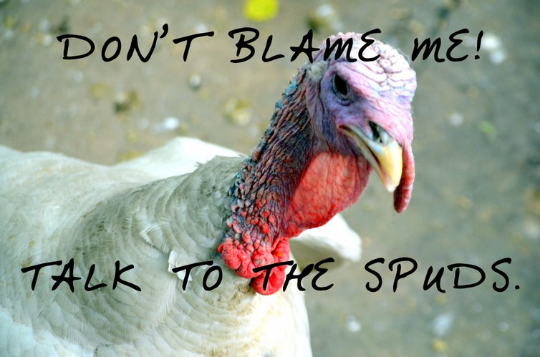
Turkey contains an amino acid called tryptophan, which can be used to promote sleep. Amino acids are the building blocks of proteins and are required for life. Tryptophan is an "essential" amino acid because the body cannot make it. Instead, you have to eat foods that contain tryptophan to get enough. You can also find tryptophan in oats, bananas, milk, eggs, peanuts and sunflower seeds. It is almost sure to be found in all common livestock and poultry.

Besides making thousands of proteins, the body uses tryptophan to make serotonin, a key brain transmitter. Serotonin plays a role in the regulation of mood. Tryptophan’s sedative effects could be related to its role in the synthesis of serotonin. Tryptophan is also necessary for making a form of vitamin B called niacin, which is important for the function of skin, nerves and the digestive tract.

What is tryptophan?
Why is tryptophan “essential”?
Which foods contain tryptophan?
What is one theory as to why you get so tired after eating your Thanksgiving meal? __________________
____________________________________________________________________________________________________________________________________________________________________________________
Name two things that the body uses tryptophan for. __
________________________________________________________________________________________
____________________________________________________________________________
What is one possible explanation as to why tryptophan makes you sleepy?
_________________________________________________________________________________
________________________________________________________________________________

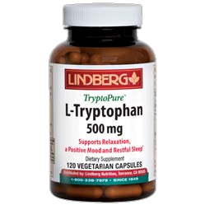
- Tryptophan supplements can be taken for insomnia (trouble sleeping). These supplements usually come in doses that range from 500 milligrams to 3,000 milligrams daily. However, a 3 ounce serving of turkey contains about 200 mg of tryptophan — about the same as chicken or beef contains and significantly less than peanuts or cheddar cheese contain.

- Additionally, the synthesis of serotonin is strictly regulated by your body, so ingesting extra tryptophan will probably not cause increased serotonin levels in the brain (recall that the sleepiness tryptophan may cause might be linked to serotonin synthesis)

- Another thing to think about is the Thanksgiving meal as a whole. How much people eat (not just of turkey, but the other dishes, as well), and what time of day they eat. When digesting food, blood flow increases to the small intestines to absorb nutrients. This may mean a temporary decrease of blood flow to other parts of the body, including the muscles and brain
Review the chart below. Graph the data by creating a bar graph. Be sure to clearly label your axes.

Tryptophan (mg per 3oz)
Turkey | 190
Chicken | 160
Beef | 180
Peanuts | 210
Cheddar Cheese | 220
Banana | 20
Oats | 60

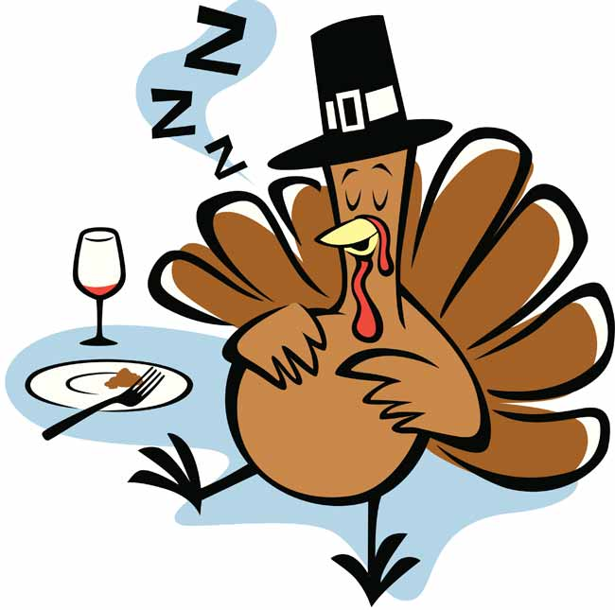

Analysis and Conclusion:

1. According to the data, which food would make you the sleepiest?

2. According to the data, which food would hypothetically make you the least sleepy?

3. Do you think that the tryptophan in turkey is primarily responsible for making you sleepy after your Thanksgiving meals? Why or why not? (Does not necessarily need to be a yes or no answer)

